Product Specifications
NAME: Human body induction switch
MODEL: SPIR-1CH-LVLN
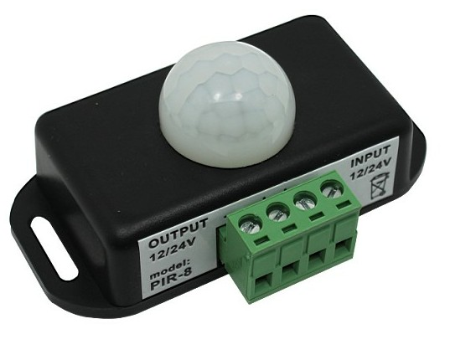
Summarization
The human body is an infrared detection sensor switch controller, the use of infrared detection control the load of the switch.Users according to actual needs, the human body sensors installed in the appropriate environment

Technical parameters
● Working temperature: -20-60 ℃
● Supply voltage: DC12/24V
● Output voltage: DC12/24V
● Output: 1 channel
● Sensing distance: 5 ~ 8 M.
● Ham should angle: 60 degrees.
● Output current: <6A
● Delay time: 1-10min (adjustable)
● External dimension: L76 Χ W45 Χ H34 mm
● Packing size: L104 Χ W64 Χ H41 mm
● Net weight: 32g
● Gross weight: 50g

External Dimension
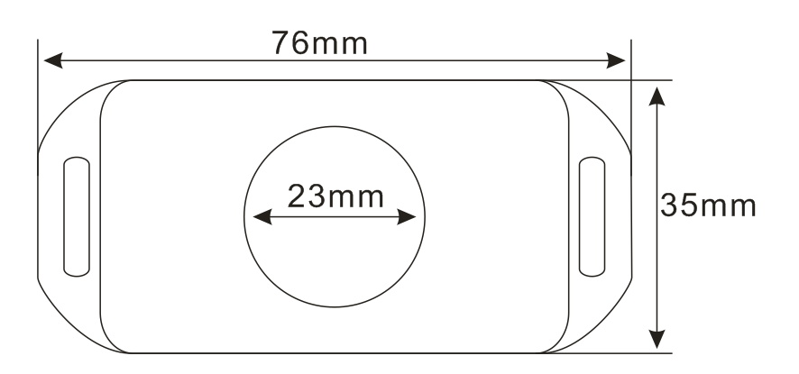
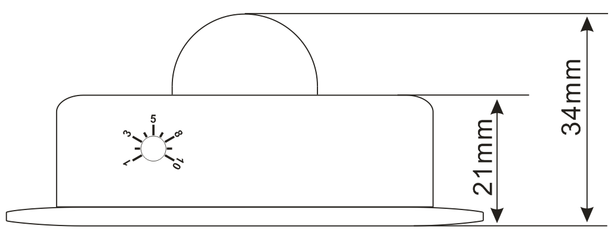
Interface Specifications
Power input interface/ Load output interface
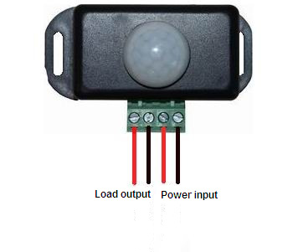
Direction for Use
1. Connect the load wire at first, following by the power wire; Please ensure short circuit can not occur between connecting wire before you turn on the power;
2. There is a time setting knob on the back of the controller, rotate the knob, you can set the delay time of human body induction switch, when detecting someone, it lights up the light, and after the time of people leaving reaches the set delay time, the light will be turn off automatically.
3. The controller signal output line and input line should be connected correctly.

Typical Application
