Product Specification

NAME: 86 type 4 channels Touch Panel Controller
MODEL: CL-RGBWLN

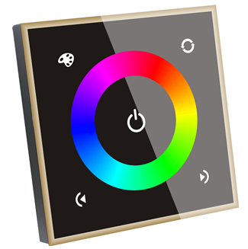

Summarization
Touch panel controller is a new high-end controller which newly developed by our company. It adopts glass panel design, beautiful and fashionable in appearance. It adopts high precision capacitance touch control chip, increases the touch sensitivity, reduces trigger which caused by mistake. It is used for controlling a variety of lamp whose source of light is LED. For instance, point source of light, flexible light strip, panel lights etc., it has many advantages such as convenient to connect, easy to use and others. This controller can control RGB and RGBW led lamp, users don't need to purchase a variety of controller, then can achieve the effect you want, also RGBW mode can realize pure white light effect that RGB lamps and lanterns can't reach.

Technical Parameters
working temperature: -20-60 ℃ supply voltage: DC12~24V
output voltage: DC12~24V output: 4 channels
connection mode: common anode external dimension: L86 * W86 * H36.7mm
packing size: L105 * W105 * H53 mm net weight: 0.131 kg
gross weight: 0.183kg static power consumption: <0.54W
output current: <4A (each channel) output power: 192W/12V, 384W/24V
External Dimension
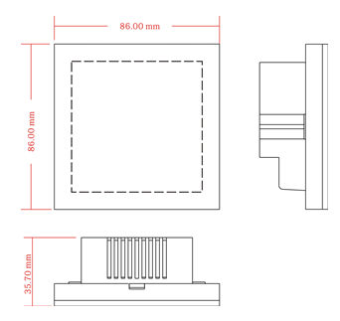

Interface Specifications：
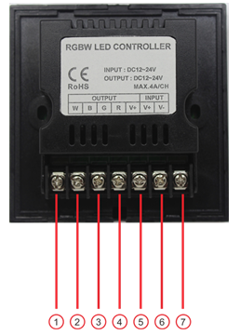
①white light output negative pole ②blue light output negative pole
③green light output negative pole ④red light output negative pole
⑤positive pole ⑥power input positive pole ⑦power input negative pole
Instruction for use:
: When touching chromatic circle, no matter in static or in dynamic mode, it can
switch into the corresponding static color on touch circle.
: you could turn on/off controller at any state; When the dimmer is turned on, long
press the key for 3 seconds, you can turn on/off output of buzzer;
: short press — switching cyclically among 39 kinds of modes, long press — can choose RGBW and RGB+W lager mode output.
: short press — switching among 7 kinds of custom Modes( the first four is red, green, blue and white, the last three is the modes you save), long press can save the modes you like, modes can be saved in the fifth, sixth, seventh mode; If you want to replace previous modes, you need first switch the modes to the one needing replaced, then find the mode you like, just long press it and save, the first four modes are fixed models.
: in static mode, brightness reduce key, total 16 levels; in dynamic mode, speed reduce key, total 16 levels;
: in static mode, brightness increase key, total 16 levels; in dynamic mode, speed increase key, total 16 levels;
Table 1 RGBW Model
NO. | Model | NO. | Model
1 | Red | 21 | Red burst flashing
2 | Orange | 22 | Green burst flashing
3 | Deep-yellow | 23 | Blue burst flashing
4 | Yellow | 24 | Yellow burst flashing
5 | Light-yellow | 25 | White burst flashing
6 | Green | 26 | Three color burst flashing
7 | Light green | 27 | Three color flash
8 | Cyan | 28 | Three color jumpy changing
9 | Light-blue | 29 | Seven color jumpy changing
10 | Sky-blue | 30 | Red fade in and out
11 | blue | 31 | Yellow fade in and out
12 | Deep-blue | 32 | Green fade in and out
13 | Blue-purple | 33 | Cyan fade in and out
14 | Purple | 34 | Blue fade in and out
15 | Brown | 35 | Purple fade in and out
16 | White | 36 | White fade in and out
17 | Ivory | 37 | Three color fade in and out
18 | Pink-white | 38 | Seven color fade in and out
19 | Yellow-white | 39 | Seven color gradual changing
20 | Blue-white

Table 2 RGB+W Model
NO. | Model | NO. | Model
1 | Red + white | 21 | Red burst flashing + white
2 | Orange + white | 22 | Green burst flashing + white
3 | Deep-yellow + white | 23 | Blue burst flashing + white
4 | Yellow + white | 24 | Yellow burst flashing + white
5 | Light-yellow + white | 25 | White burst flashing + white
6 | Green + white | 26 | Three color burst flashing + white
7 | Light green + white | 27 | Three color flash + white
8 | Cyan + white | 28 | Three color jumpy changing + white
9 | Light-blue + white | 29 | Seven color jumpy changing + white
10 | Sky-blue + white | 30 | Red fade in and out + white
11 | Blue + white | 31 | Yellow fade in and out + white
12 | Deep-blue + white | 32 | Green fade in and out + white
13 | Blue-purple + white | 33 | Cyan fade in and out + white
14 | Purple + white | 34 | Blue fade in and out + white
15 | Brown + white | 35 | Purple fade in and out + white
16 | White + white | 36 | White fade in and out + white
17 | Ivory + white | 37 | Three color fade in and out + white
18 | Pink-white + white | 38 | Seven color fade in and out + white
19 | Yellow-white + white | 39 | Seven color gradual changing + white
20 | Blue-white + white
Typical Application
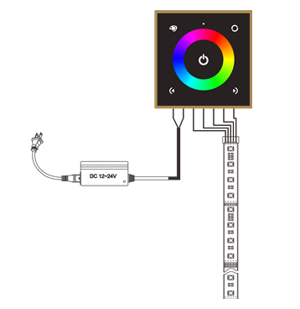
Installation Method
1. Connection
Connect the wire according to the typical application circuit. Please don’t connect the wire in the opposite way.

2. open touch panel
Gently pry gaps in touch panel with a screwdriver, and then you can slowly remove the panel, as shown below;
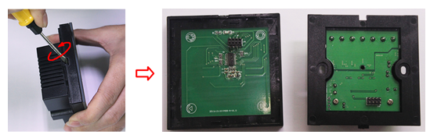

3. Install switch base
As shown in the picture, mount the controller on the cassette in the wall after connecting the wire, and then nail the screw, fix it on the wall, finally you can install the switch pedestal on the wall;
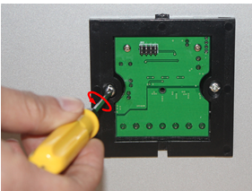
4. Cover the touch panel
Look the panel direction, then cover panel, as shown in the figure;
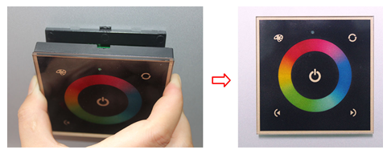

Remarks
1. Connect the load wire at first, followed by the power wire; Please ensure short circuit can not occur between connecting wire before you turn on the power;
2. The supply voltage of controller ranges in DC12-24V, it may burn out the controller once exceed the voltage.

