Product Specifications

NAME: Touch Panel Full-color Controller
MODEL: CL-RGB04

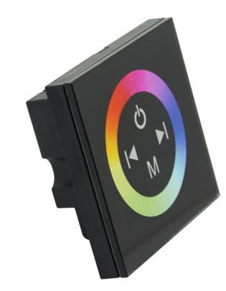
Summarization
Touch panel controller is a new high-end controller which newly developed by our company. It adopts glass panel design, is beautiful and fashionable in appearance. It adopts high precision capacitance touch control chip, increases the touch sensitivity, reduces trigger which caused by mistake. It is used for controlling a variety of lamp whose source of light is LED. For instance, point source of light,flexible light strip, wall washer lamp, panel lights etc., it has many advantages such as convenient to connect, easy to use and others. According to the actual need of customers,it can carry out jumpy changing,gradual changing,stroboflash and other effects of change.

Technical Parameters
● working temperature: -20-60 ℃
● supply voltage: DC12-24V
● output: 3 channels
● connection mode: common anode
● external dimension: L86 Χ W86 Χ H36 mm
● packing size: L115Χ W110 Χ H56 mm
● net weight: 128g
● gross weight: 187g
● static power consumption: <1W
● output current: <4A( each channel )
● output power: 12V<144W,24V<288W

External Dimension
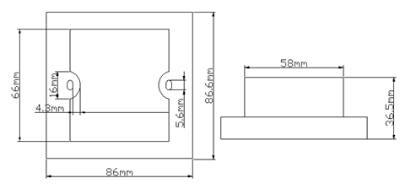
Interface Specifications
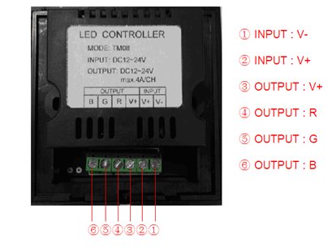
Controller instruction:
1.Touch panel there are 4 buttons and a pulley key, the functions are as follows:
: you could turn on/off controller at any state;
: mode key, you can choose a different kind of color change, total 11 kinds of change
patterns, press the key for long time, you can turn on/ off the voice prompts;
: It is used for increasing the output signal brightness or speed, once pressed, the series of
brightness or speed increase 1, total 100 series;
: It is used for reducing the output signal brightness or speed;
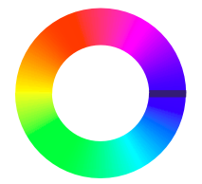
Multicolor pulley touch key, color mode selection key, up to 64 touch points.
The button has two functions:
1) Pulley color selection key, so when the current control mode is M key mode (color), if must realize pulley static color, you can press this key.
2) Pulley color switch key, can change from 64 kinds of colors (as the pulley shown)

- standard change is shown in the below table:

Mode No. | Function | Remarks
1 | Static red | Brightness is adjustable, speed is unadjustable.
2 | Static green | Brightness is adjustable, speed is unadjustable.
3 | Static blue | Brightness is adjustable, speed is unadjustable.
4 | Static yellow | Brightness is adjustable, speed is unadjustable.
5 | Static purple | Brightness is adjustable, speed is unadjustable.
6 | Static cyan | Brightness is adjustable, speed is unadjustable.
7 | Static white | Brightness is adjustable, speed is unadjustable.
8 | Three-color jumpy changing | Speed is adjustable, brightness is unadjustable
9 | Three-color gradual changing | Speed is adjustable, brightness is unadjustable
10 | Seven-color jumpy changing | Speed is adjustable, brightness is unadjustable
11 | Seven-color gradual changing | Speed is adjustable, brightness is unadjustable

Typical Application
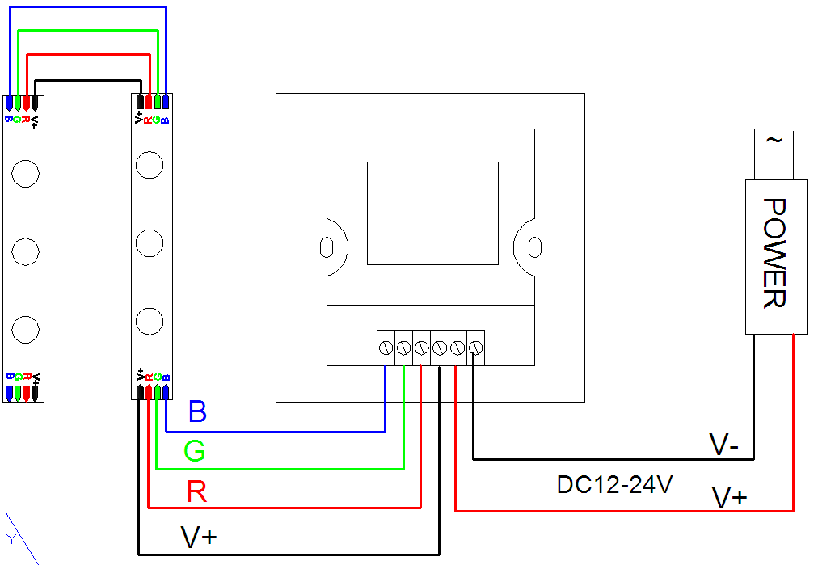

Installation Method
(1) gently pry gaps in touch panel with a screwdriver, and then you can slowly remove the panel, as shown below;
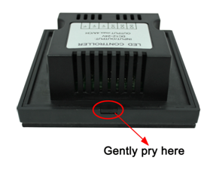
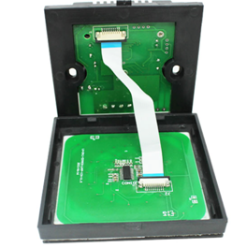
(2) remove the cable. Pull the locking of the terminal transposon, and then you can slowly remove the cable, as shown below:
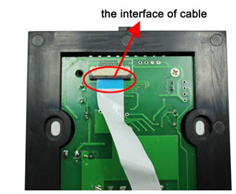
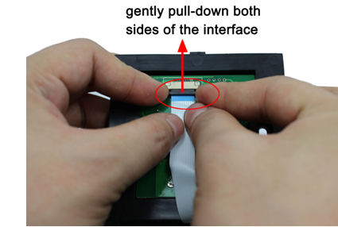
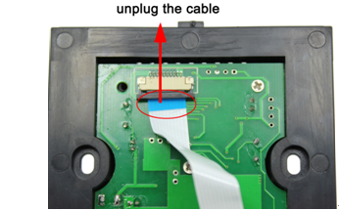
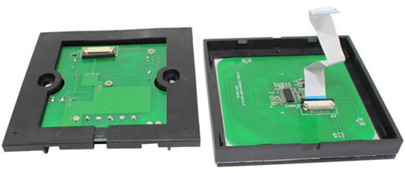
- Fix the base of controller in the 86×86 installation box (customers need to buy the installation box by themselves) on the wall with screws.
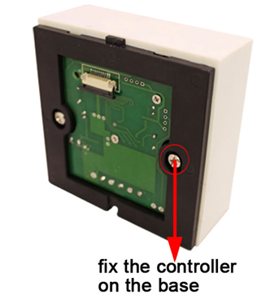
- use your hand gently pull down the cable seat lock according to step 2, plug the cable into cable seat, press the lock, and mount the cable of panel on the base, as shown below:
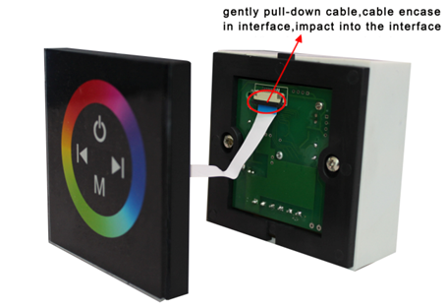
- installation is completed, as shown below:
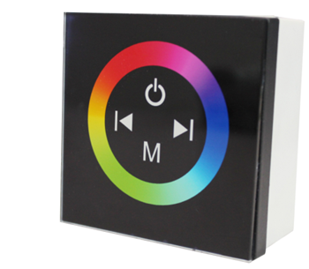
Remarks:
1. Connect the load wire at first, following by the power wire; Please ensure short circuit can not occur between connecting wire before you turn on the power;
2.The supply voltage of controller ranges in DC12V~DC24V, it may burn out the controller once exceed the voltage ranges.

