CL-RGB02 Touch Panel RGB Controller

Products Specifications

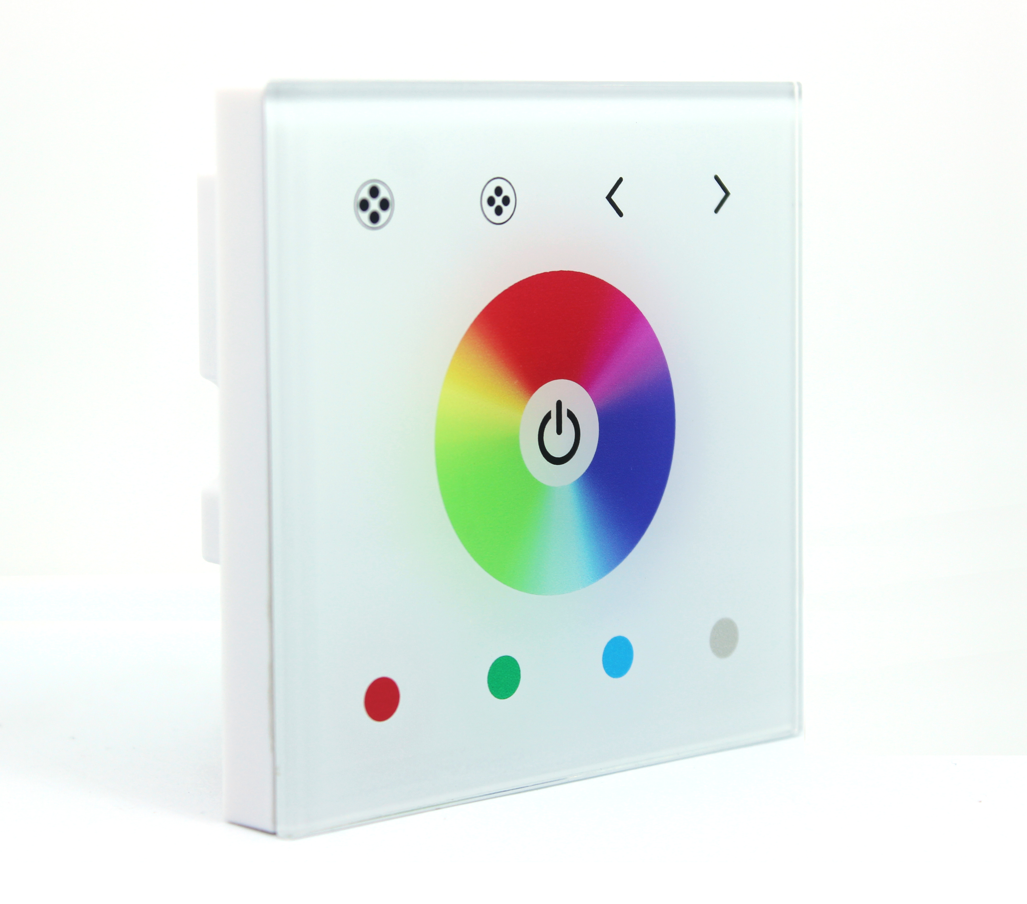

Contents

1. Summarization....................................................................2

2. Technical Parameters..............................................................2

3. External Dimension................................................................2

4.Interface Specifications..........................................................3

5. Panel key instructions............................................................4

6. Typical Application..............................................................5

7. Remark...........................................................................5

1.Summarization
Touch panel controller is a kind of new high-end controller which newly developed by our company. It adopts glass panel design with beautiful and fashionable appearance. It adopts high precision capacitance touch control chip, increases the touch sensitivity, and reduces trigger which caused by mistake. It is used to control a variety of lamp whose source of light is LED. For instance, point source of light,flexible light strip, wall washer lamp, glass curtain wall light etc.. It has many advantages such as convenient to connect, easy to use and so on.

2.Technical Parameters
2.1 working temperature：-20-60℃
2.2 supply voltage：DC12~24V
2.3 output：3 channels
2.4 connect mode：common anode
2.5 packing size：L105*W105*H53mm
2.6 net weight： 137g
2.7 gross weight： 187g
2.8 static power consumption：<1W
2.9 output current：<4A(each channel)
2.10 output power：12V:<144W, 24V:<288W

3.External Dimension
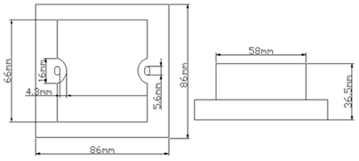

4.Interface Specifications

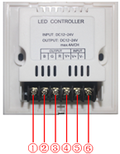
①：blue light cathode；② green light cathode；③ red light cathode；④common anode；⑤input power anode；⑥input power cathode。

5.Panel key instructions
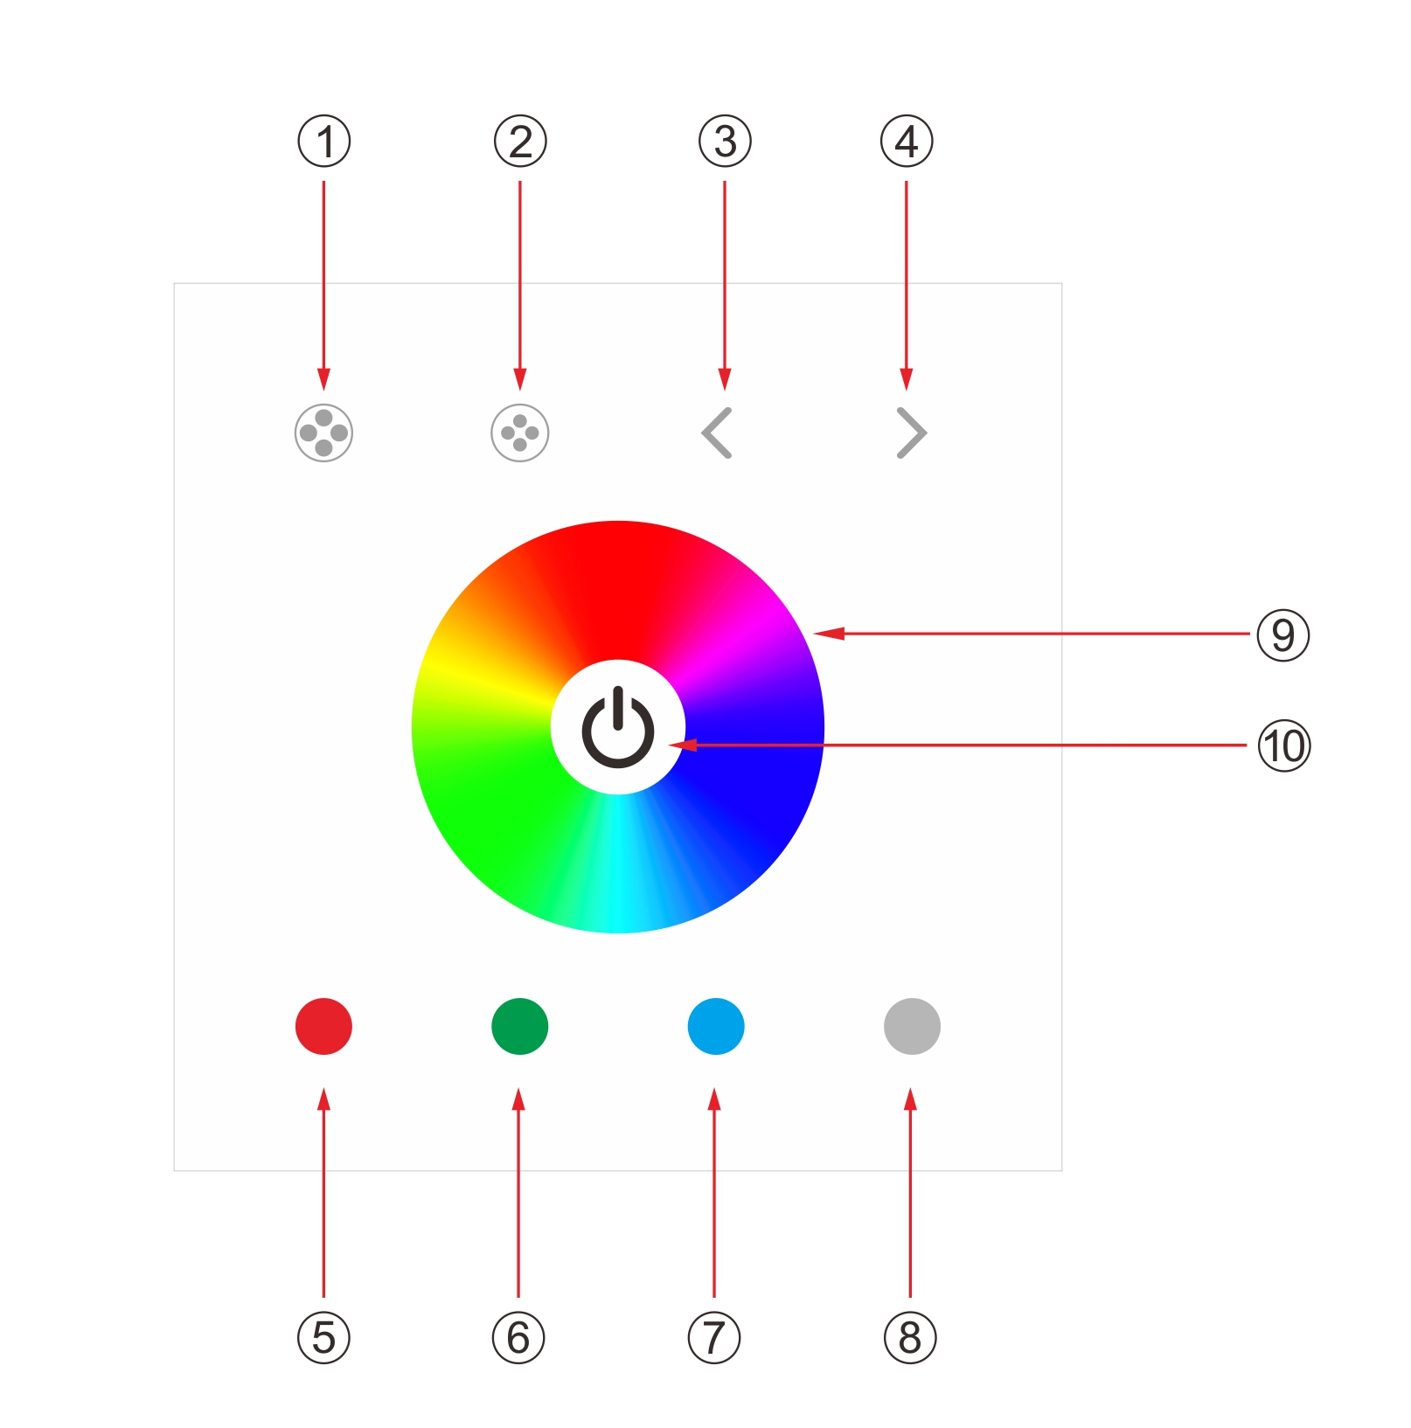

①:mode increase——when the controller is open, mode can be increased(the highest is 21)
②:mode reduce——when the controller is open, mode can be reduced(the lowest is 1)

③:speed/brightness reduce key——when the controller is open ,brightness of light can be reduced in static mode(the lowest level is 1); speed of light can be reduced in dynamic mode(the lowest level is 1)
④:speed/brightness increase key——when the controller is open, brightness of light can be increased in static mode(the highest level is 100); speed of light can be increased in dynamic mode(the highest level is 100)

⑤:static red——when the controller is open, lamp can be changed to static red.
⑥:static green——when the controller is open, lamp can be changed to static green.
⑦:static blue——when the controller is open, lamp can be changed to static blue.
⑧:static white——when the controller is open, lamp can be changed to static white.
⑨:cor circle——when the controller is open, lamp can be changed to corresponding color when color circle is touched.
⑩:on/off key——to control the open and close of lamp when power on，or press for a long time to close and open the buzzer .
5.2 controller mode choice change as follows:

No | Patterns | Remarks | No | Patterns | Remarks
1 | Static red | Brightness is adjustable,Speed is unadjustable. | 12 | Red stroboflash | Speed and  Brightness  are adjustable
2 | Static blue | Brightness is adjustable,Speed is unadjustable. | 13 | Blue stroboflash | Speed and  Brightness  are adjustable
3 | Static purple | Brightness is adjustable,Speed is unadjustable. | 14 | Purple stroboflash | Speed and  Brightness  are adjustable
4 | Static green | Brightness is adjustable,Speed is unadjustable. | 15 | Green stroboflash | Speed and  Brightness  are adjustable
5 | Static yellow | Brightness is adjustable,Speed is unadjustable. | 16 | Yellow stroboflash | Speed and  Brightness  are adjustable
6 | Static cyan | Brightness is adjustable,Speed is unadjustable. | 17 | Cycan stroboflash | Speed and  Brightness  are adjustable
7 | Static white | Brightness is adjustable,Speed is unadjustable. | 18 | White stroboflash | Speed and  Brightness  are adjustable
8 | Three-color jumpy changing | Speed and brightness are adjustable | 19 | R/B crossfade | Speed is adjustable,  brightness is unadjustable
9 | Seven-color jumpy changing | Speed and brightness are adjustable | 20 | B/G crossfade | Speed is adjustable,  brightness is unadjustable
10 | Three-color gradual changing | Speed is adjustable,brightness is unadjustable | 21 | G/R crossfade | Speed is adjustable,  brightness is unadjustable
11 | Seven-color gradual changing | Speed is adjustable,brightness is unadjustable

7.Typical Application

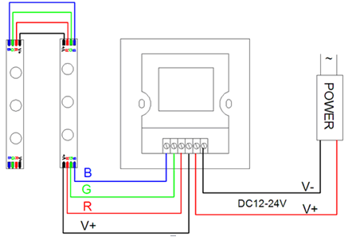
8.Remark
1. Connect the load wire at first, following by the power wire; Please ensure there is no short circuit between input and out put connecting wire before power on;
2.The supply voltage of controller ranges in DC12V~DC24V, it may burn out the controller once exceed the voltage ranges.

