Product Specification

NAME: Touch Panel Dimmer
MODEL: CL-DM01

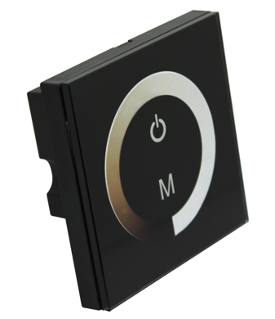
Summarization
Touch panel controller is a new high-end controller which newly developed by our company. It adopts glass panel design, is beautiful and fashionable in appearance. It adopts high precision capacitance touch control chip, increases the touch sensitivity, reduces trigger which caused by mistake. It is used for controlling a variety of lamp whose source of light is LED. For instance, point source of light,flexible light strip, panel lights etc., it has many advantages such as convenient to connect, easy to use and others.

Technical Parameters
● working temperature: -20-60 ℃
● supply voltage: DC12~24V
● output: 1 channel
● connection mode: common anode
● external dimension: L86 Χ W86 Χ H36 mm
● packing size: L115 Χ W110 Χ H56 mm
● net weight: 126g
● gross weight: 185g
● static power consumption: <1W
● output current: <8A
● output power: 12V<96W, 24V<192W

External Dimension
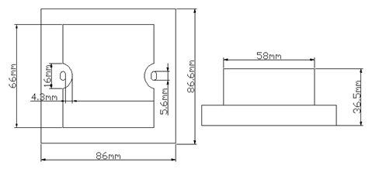

Interface Specifications
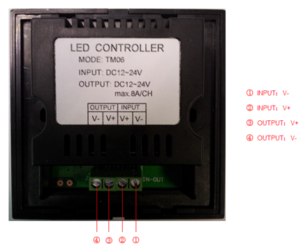
Controller instruction:

1. Touch panel has two buttons and a pulley key, the functions are as follows:
you could turn on/off controller at any state;
: the key is used for choosing the brightness. You can choose different brightness. total 10

kinds of change patterns. Press the key for long time, you can turn on/ off the buzzer;
Pulley touch button, promise brightness selection key, up to 64 touch points.
The key has two functions:
- pulley brightness select key, so when the current control mode is M key mode (color),
if must realize pulley brighness, you can press this key.
2) Pulley brightness switch key, can change from 64 kinds of static brightness (as
the pulley shown)
- standard change is shown in the below table:
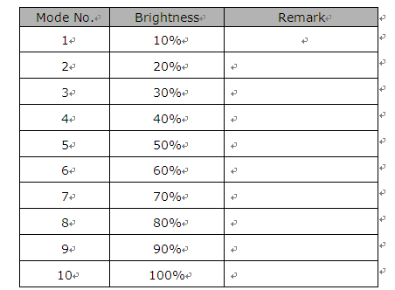
Typical Application
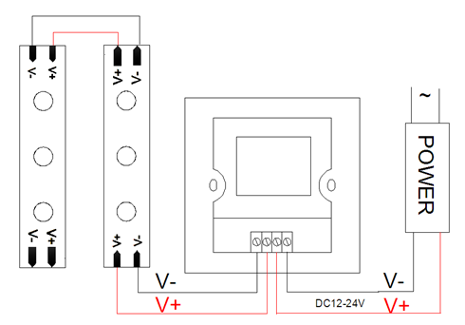

Installation Method

- gently pry gaps in touch panel with a screwdriver, and then you can slowly remove the panel, as shown below;
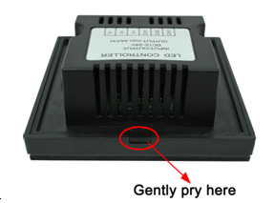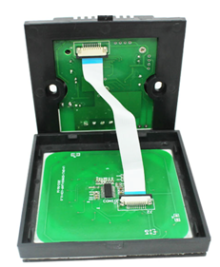

(2) remove the cable. Pull the locking of the terminal transposon, and then you can slowly remove the cable, as shown below:
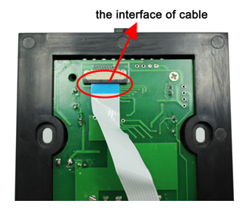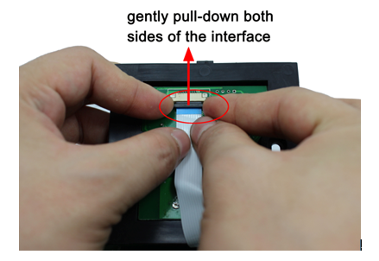

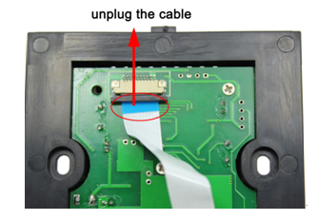
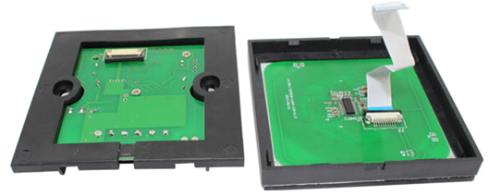
- Fix the base of controller in the 86×86 installation box (customers need to buy the installation box by themselves) on the wall with screws.
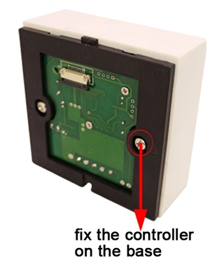
- use your hand gently pull down the cable seat lock according to step 2, plug the cable into cable seat, press the lock, and mount the cable of panel on the base, as shown below:
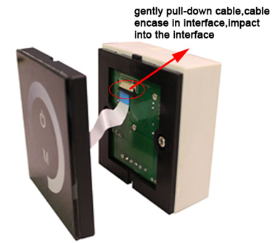
- installation is completed, as shown below:
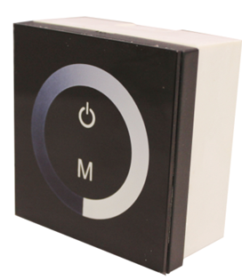

Remarks:
1. Connect the load wire at first, following by the power wire; Please ensure short circuit can not occur between connecting wire before you turn on the power;
2.The supply voltage of controller ranges in DC12V~DC24V, it may burn out the controller once exceed the voltage ranges.

